1. To test whether all the front-end components are working, we can use the Simulator. To run the Simulator, press the ‘arrow’ button in the top left. If the build succeeds you will see:

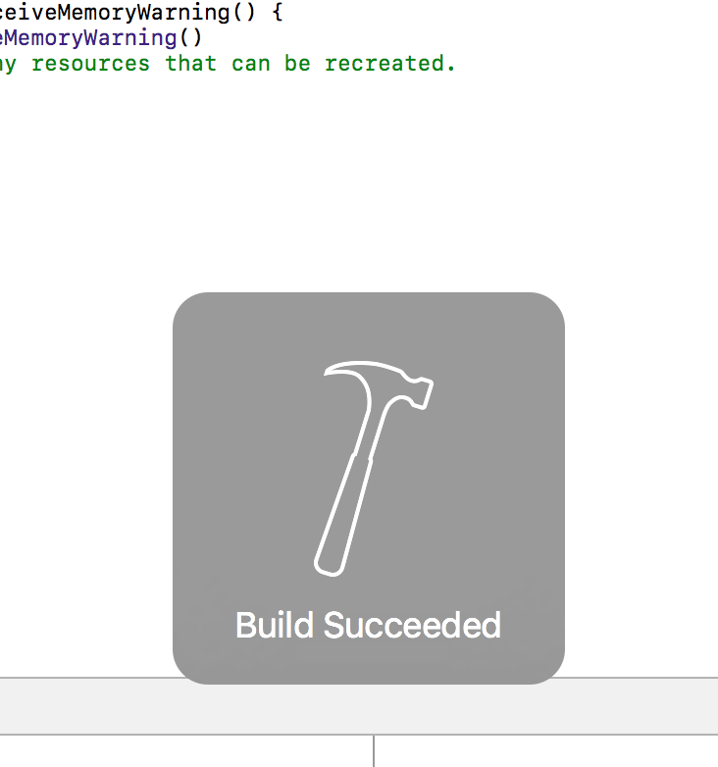



1. If the build fails, it is most likely because of errors in different files. To test using the Simulator even if there are errors, right-click on the files with the errors, click on Delete and then select ‘Remove Reference to Files.’
2. If the Simulator renders everything properly, go ahead and click on the ‘Sign Up’ or ‘Sign In’ which should lead you to the respective screens. Also make sure the back-buttons on each page work (they should lead back to the landing page).

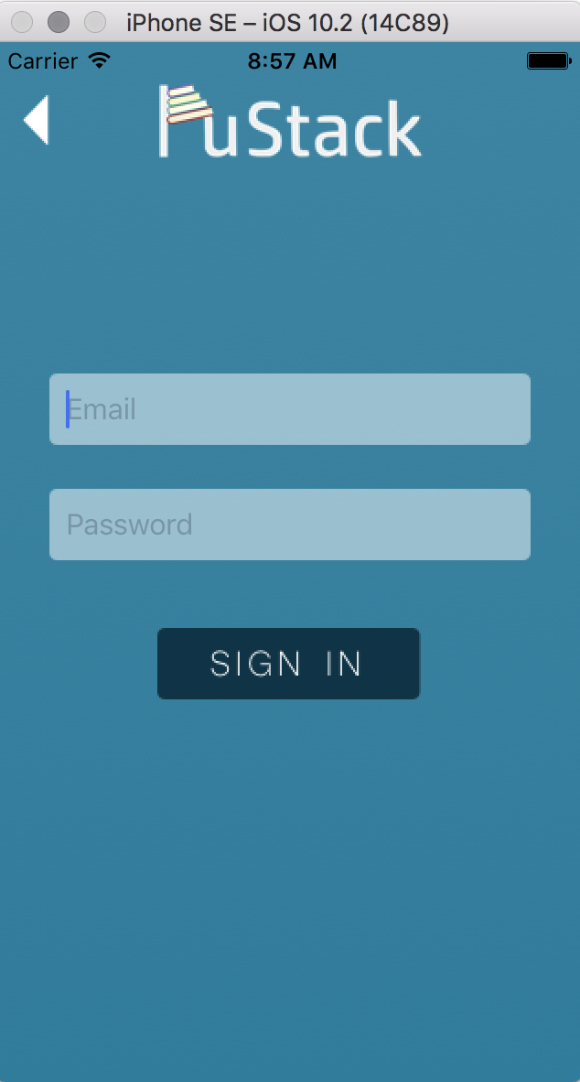

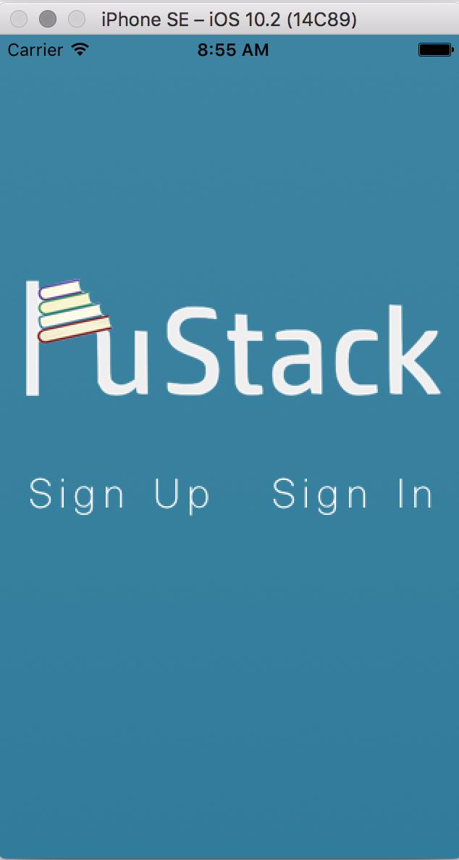

1. A very common error that can occur is when the Simulator doesn’t detect a landing page so it cannot open the Storyboards. To fix this go to the Storyboards file and then make sure that your preferred screen is the ‘initial view controller.’:
2. On the ‘Sign In’ or ‘Sign Up’ page, make sure that you can write in the text fields. You should be able to click in the fields and a cursor image should appear. Test it out by typing something on the keyboard.

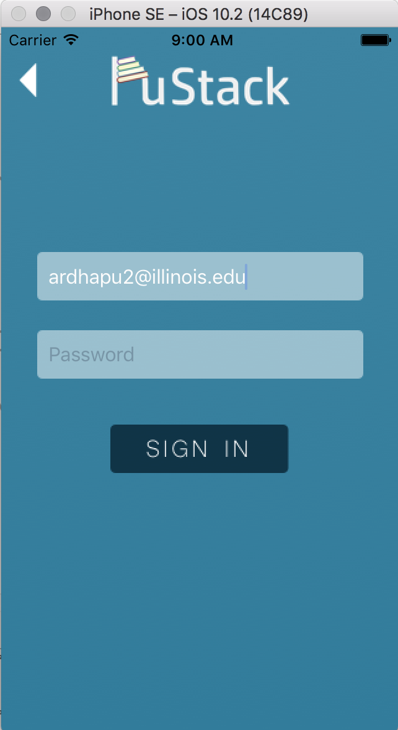

1. On the Sign Up Page, there are a few things you need to test. If you don’t fill any of the blanks and press ‘Sign Up’ it should give you a error message:

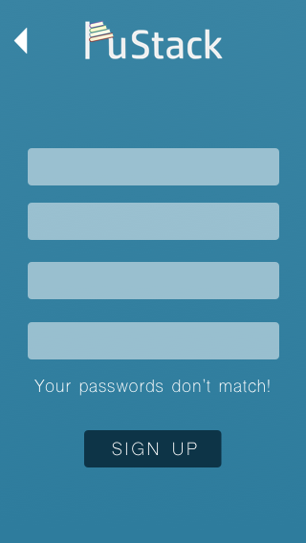

1. If your passwords don’t match, it should give you this error:



1. If you have successfully signed up, it should give you this message:

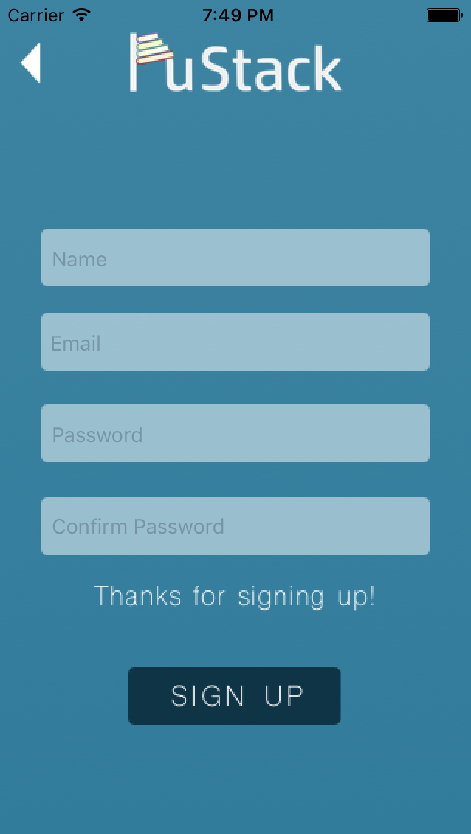

1. Go back to the landing page and click on Sign In to login with your newly formed user account. As with Sign Up, we need to check and see if everything works properly. If you don’t fill in all the fields you get this error:

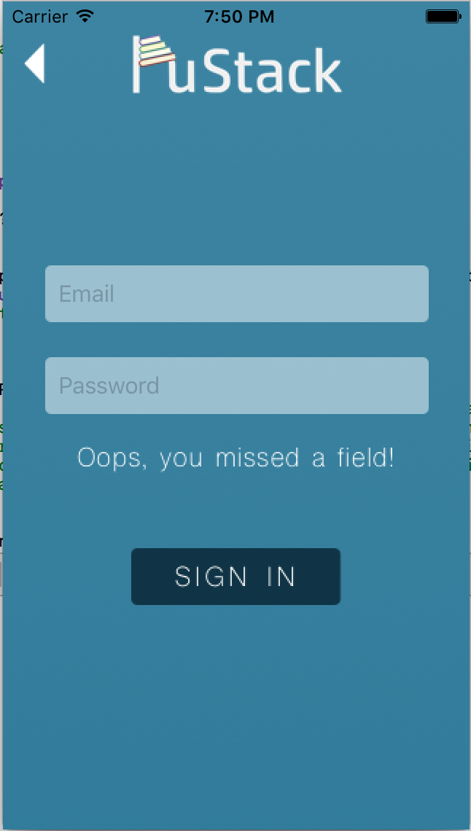

1. If you fill in the wrong information it should give you this error message:

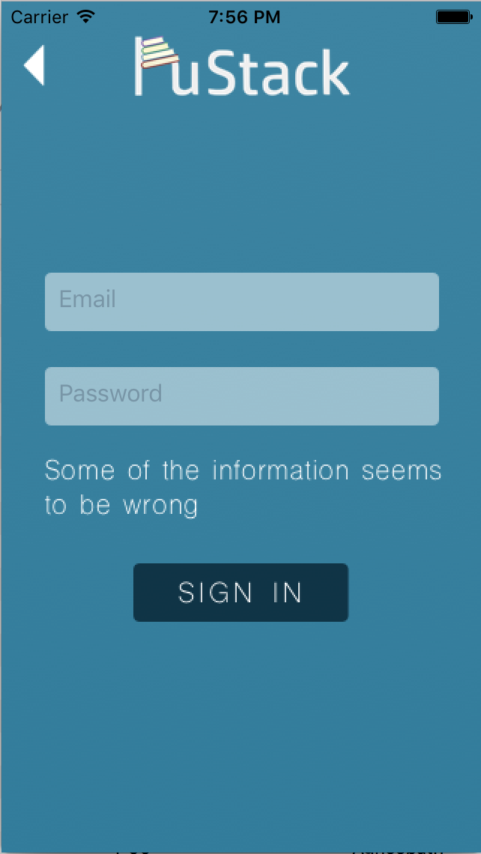

1. Signing in with the correct credentials should lead to this screen. Clicking on the buttons on this individual screen leads to:

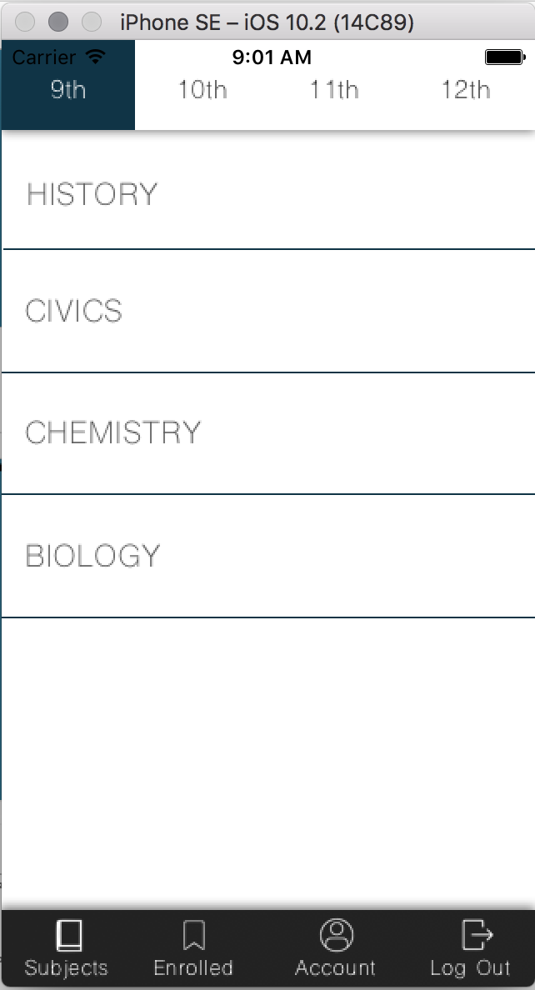

1. There are several subjects displayed on this page. Currently there are only topics for History available. Clicking on the other subjects should show this message:

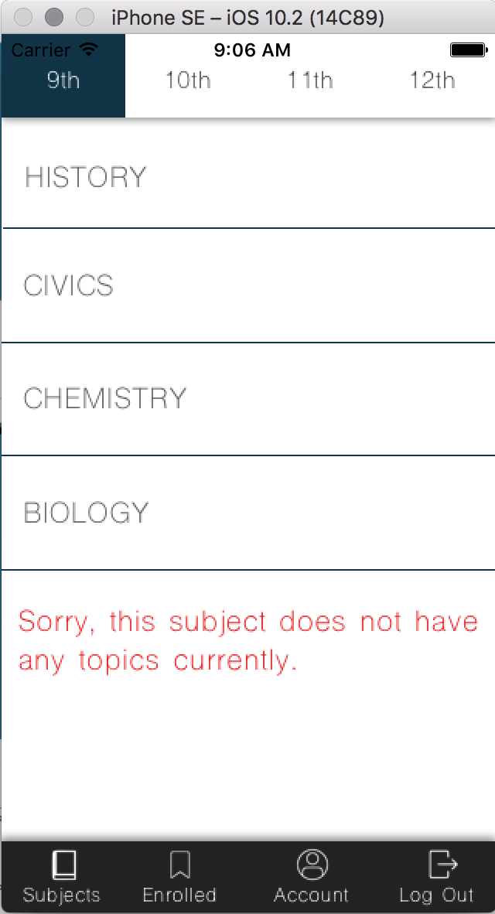

1. The navbar at the top has different sections each of which should be highlighted when pressed on.

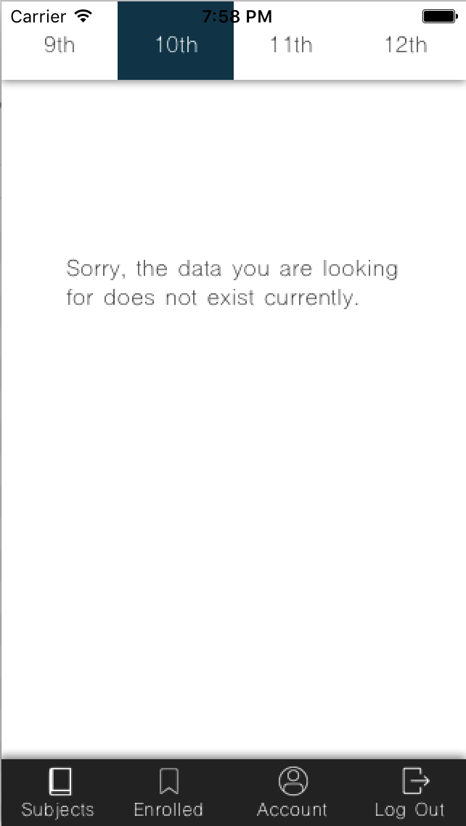

1. Clicking on the ‘Enroll’ button allows users to save that course for a later time. Ideally a message should pop-up stating that the course has been added to the user’s saved courses.

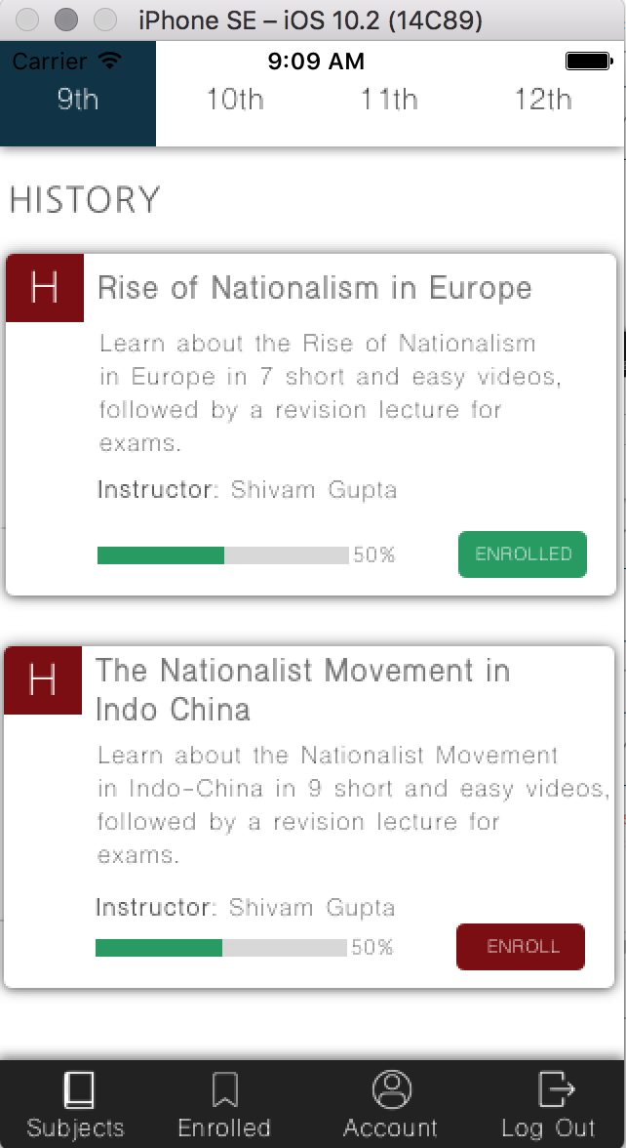

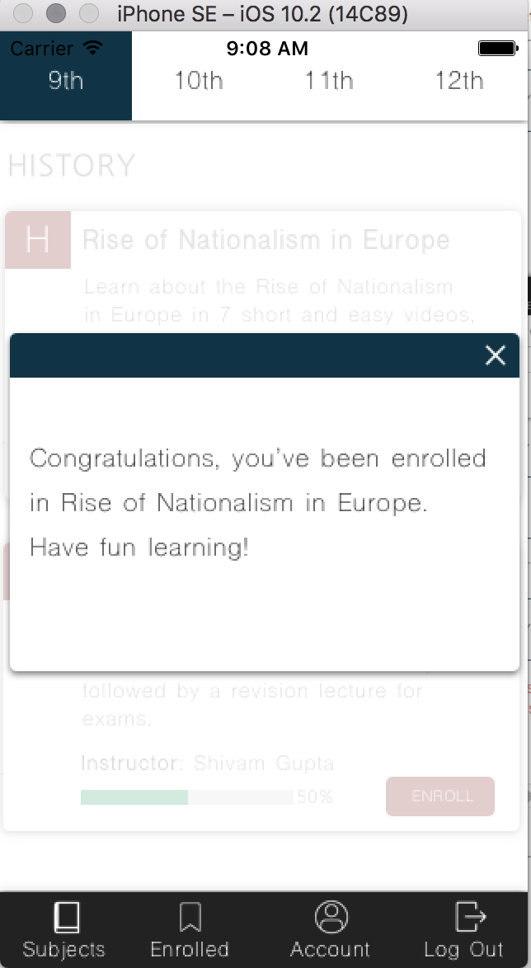

1. Clicking on the navbar should lead to different sections of the app. Clicking on enrolled should lead to the courses that you are currently enrolled in.

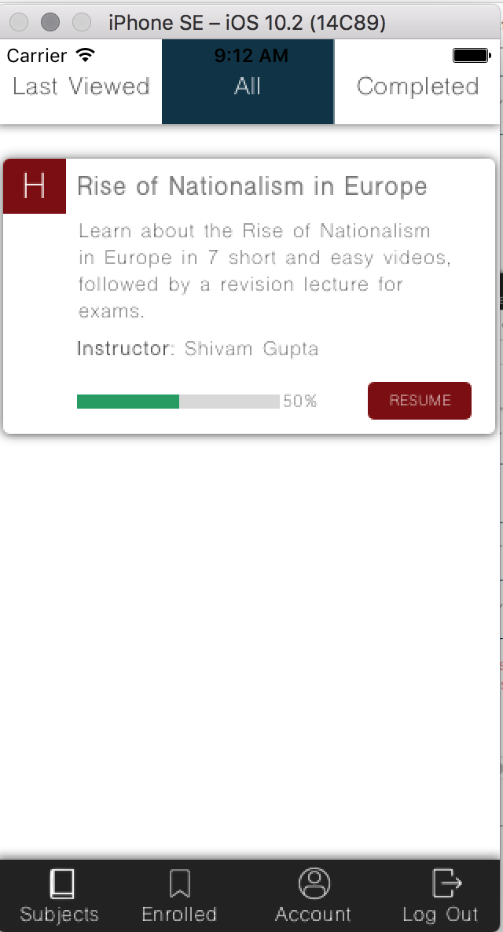

1. Like the previous screen, the navbar at the top should highlight different sections when clicked on.
2. On the previous screen, pressing on the ‘Resume’ button should lead to the videos that the user can watch.
3. Pressing the cross button at the top of the screen leads back to the enrolled courses page.
4. Clicking on the navicon opens up another navbar that has all the different topics and videos.

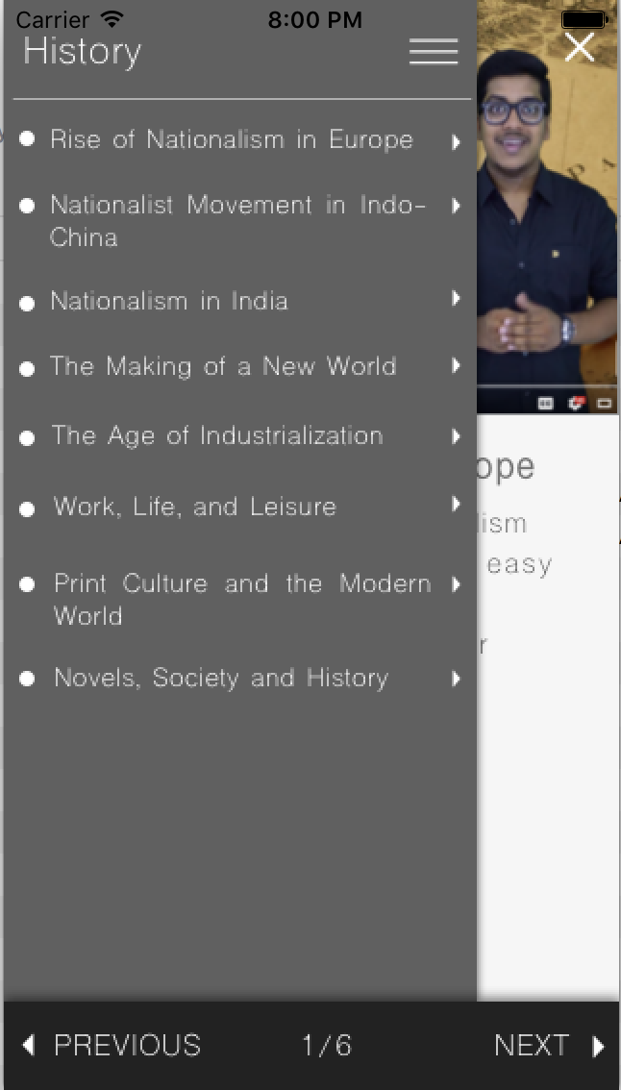

1. Pressing on each topic should create a tree-view navbar in that the next level with all the videos should show. Pressing the back-button leads back to the previous level.

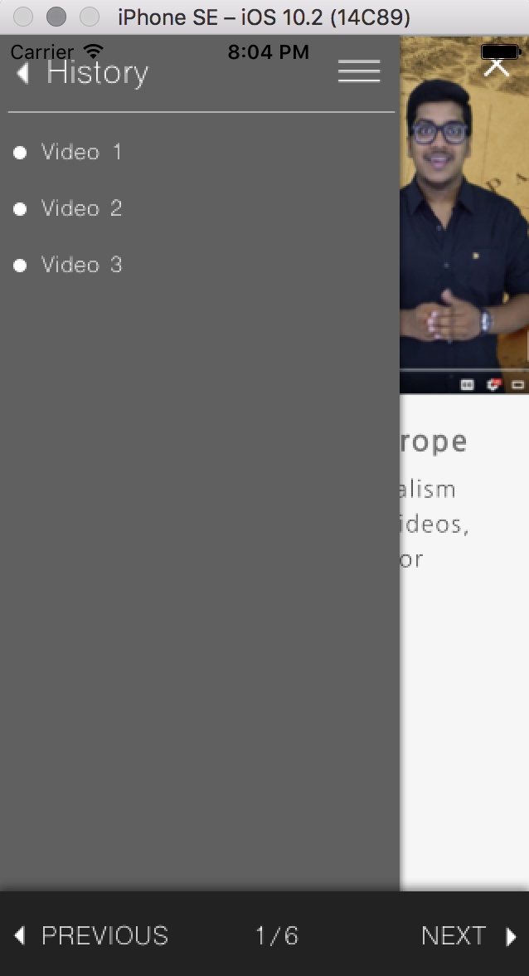

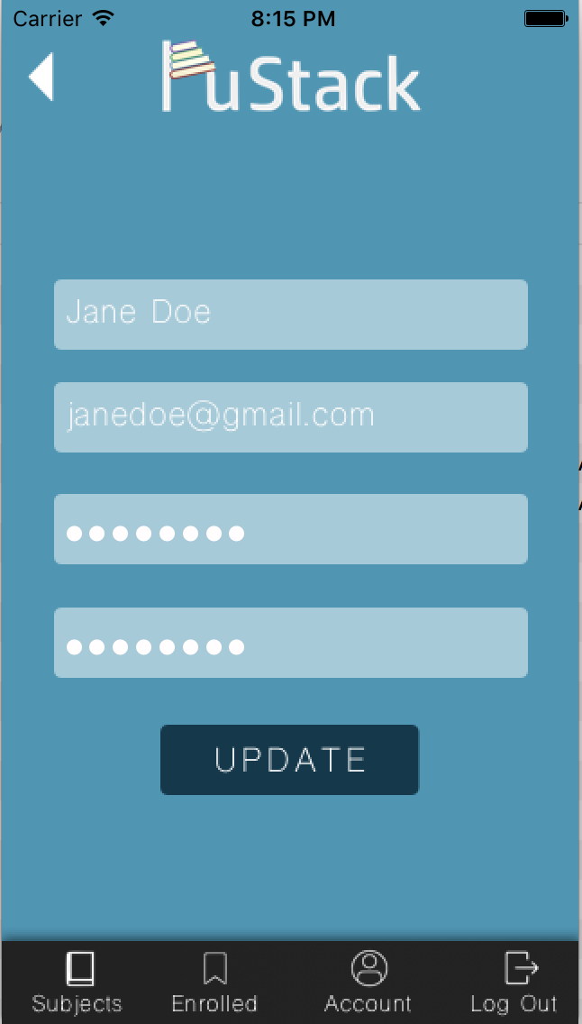

1. To update your account information press on the account button at the bottom and you’ll see a screen like this:
2. You can change the fields and press update to get this:

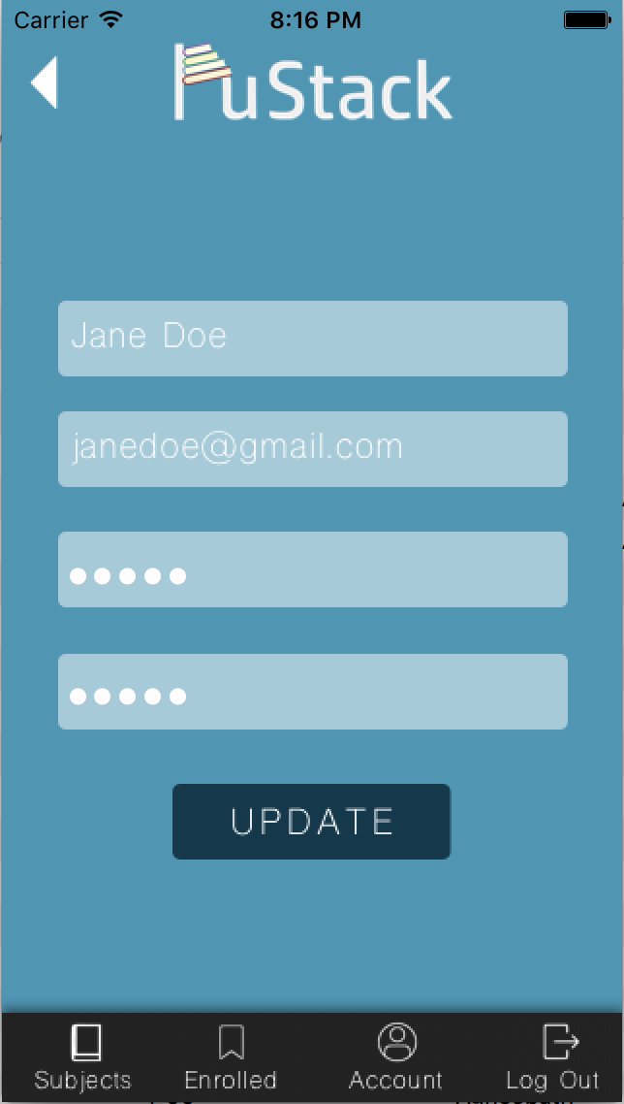

1. Clicking on the Log Out button in the navbar at the bottom should lead back to the landing page (once we have connected the models, ideally all the user data that is stored is wiped).